ASSIGNMENT FRONT SHEET <No.3>
Qualification | BTEC Level 5 HND Diploma in Computing and Systems Development
Unit number and title | Unit 18: Procedural Programming
Assignment due |  | Assignment submitted
Learner’s name | Nguyễn Ngọc Chấn | Assessor name | Trần Phước Sinh

Learner declaration:
I certify that the work submitted for this assignment is my own and research sources are fully acknowledged.
Learner signature |  | Date

Grading grid
P4.4 | P4.5 | M1 | M2 | M3 | D1 | D2 | D3

Assignment title | Help system and technical documentation
In this assignment, you will have opportunities to provide evidence against the following criteria.
Indicate the page numbers where the evidence can be found.

Assessment criteria | Expected evidence | Task no. | Assessor’s Feedback
LO4. Be able to test procedural programming solutions
4.4 Create onscreen help to assist the users of a computer program | On screen help  - General help  - Contextual help  - Annotated code listing | 1
4.5 Create documentation for the support and maintenance of a computer program | Technical documentation | 2

Assessment criteria | Expected Evidence | Feedback  (note on Merit/Distinction if applicable)
Merit descriptor No. (M1)
Merit descriptor No. (M2)
Merit descriptor No. (M3)
Distinction descriptor No. (D1)
Distinction descriptor No. (D2)
Distinction descriptor No. (D3)

Summative feedback

Assessor’s Signature |  | Date

4.4 Create onscreen help to assist the users of a computer program
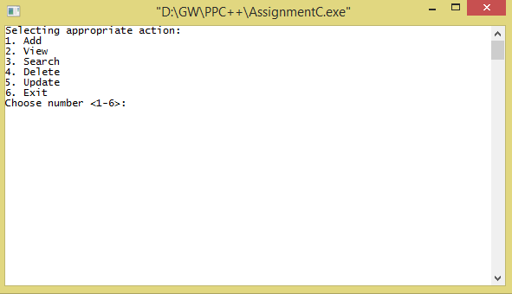
Click on app.exe on the desktop, the program will launch main menu as below
Figure: Main menu
Control | Details
- Add | Enter ‘1’: will allow user to add new student
- View | Enter ‘2’: will allow user to view all students’ information
- Search | Enter ‘3’: will allow user to search student via student id
- Delete | Enter ‘4’: will allow user to remove student from the system
- Update | Enter ‘5’: will allow user to update student’s information
- Exit | Enter ‘6’: will exit program

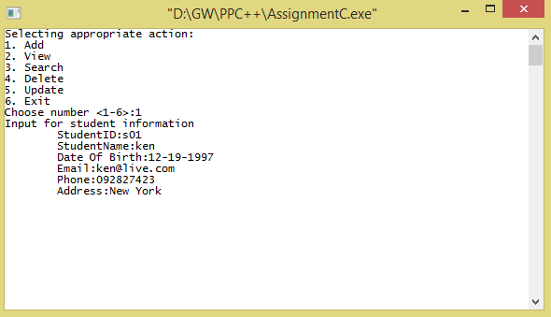
Enter ‘1’: the program will navigate to add new student as below

Figure: Add new student feature
Control | Details
StudentID | Enter student id
StudentName | Enter student name
Date Of Birth | Enter student date of birth
Email | Enter student email
Phone | Enter student phone number
Address | Enter student address

Enter ‘3’: the program will navigate to search student as below
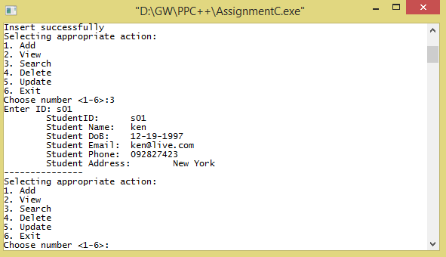
Figure: Search student
Control | Details
StudentID | Enter student id to search

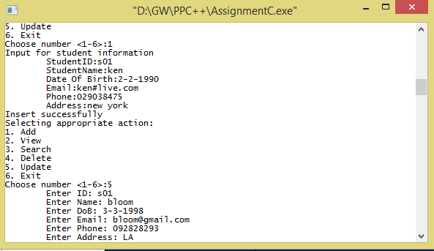
Enter ‘3’: the program will navigate to update student as below

Figure: Update student’s information
Control | Details
StudentID | Enter student id
StudentName | Enter student name
Date Of Birth | Enter student date of birth
Email | Enter student email
Phone | Enter student phone number
Address | Enter student address

4.5 Create documentation for the support and maintenance of a computer program
System Requirements for the application Student Management System application version 1.0
- Minimum 512 MB RAM
- Operating system Linux/ Windows/ Mac
- Hard Disk Space 100 MB
Compiling and Running Application
- Double click on app.exe on the desktop, the program will launch main menu
Main menu will be display if you run successfully:

SMS Flow Diagram

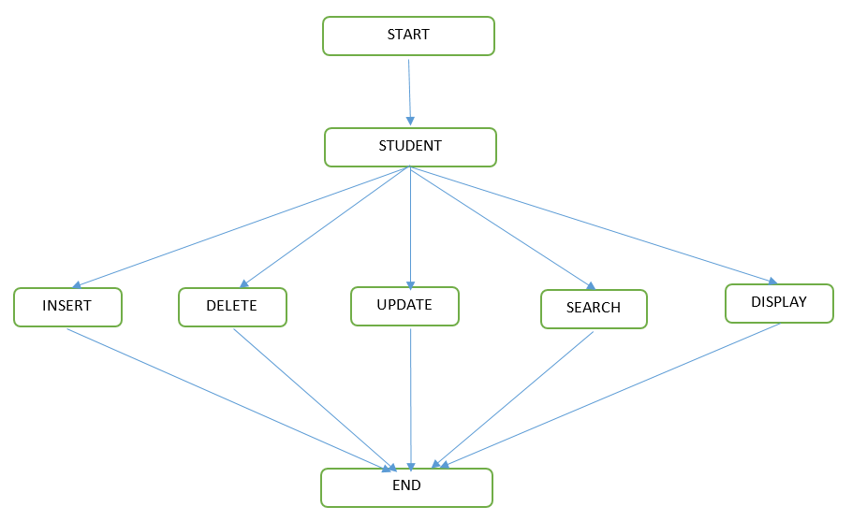

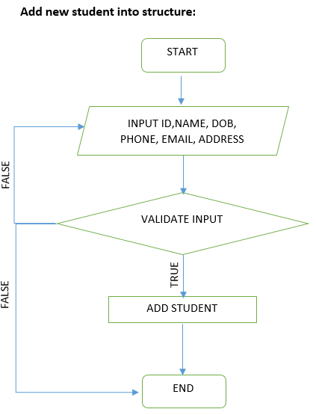
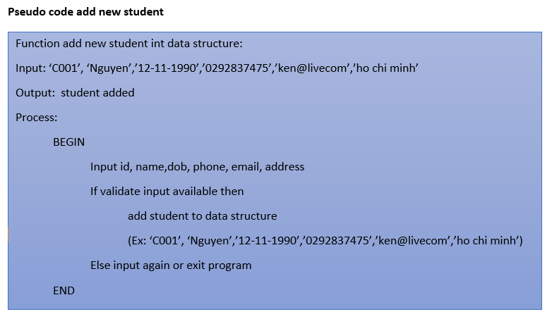
Below flow chart displays the details on how this application works:

Flow of application :
- User accesses the application
- The application will allow to perform the below set of operations:
  - Add new student
  - Remove student
  - Update student
  - Search student
  - View all student

Conclusion
This application has been made to understand the basic concepts and features of C programming and desktop applications. It helped me enhancing my C programming skills. I have got the better understanding of C programming. I have achieved the clarity in implementing programming solution through designing models such as UML class diagram and so on. The student management system has been made according to the requirements specified in the case study.

